1.

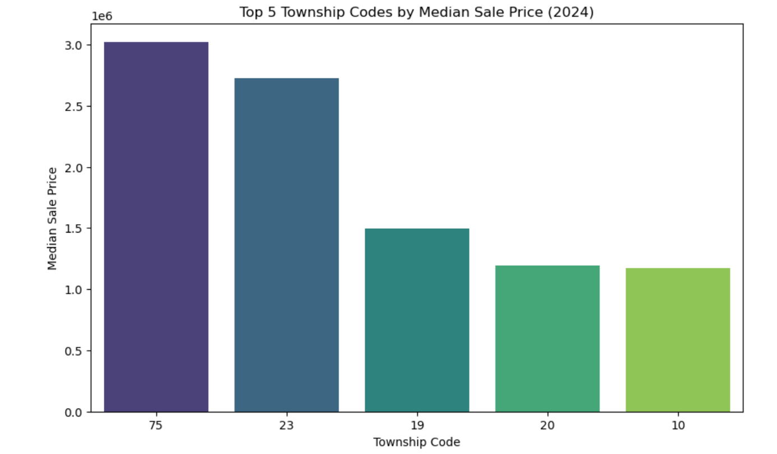

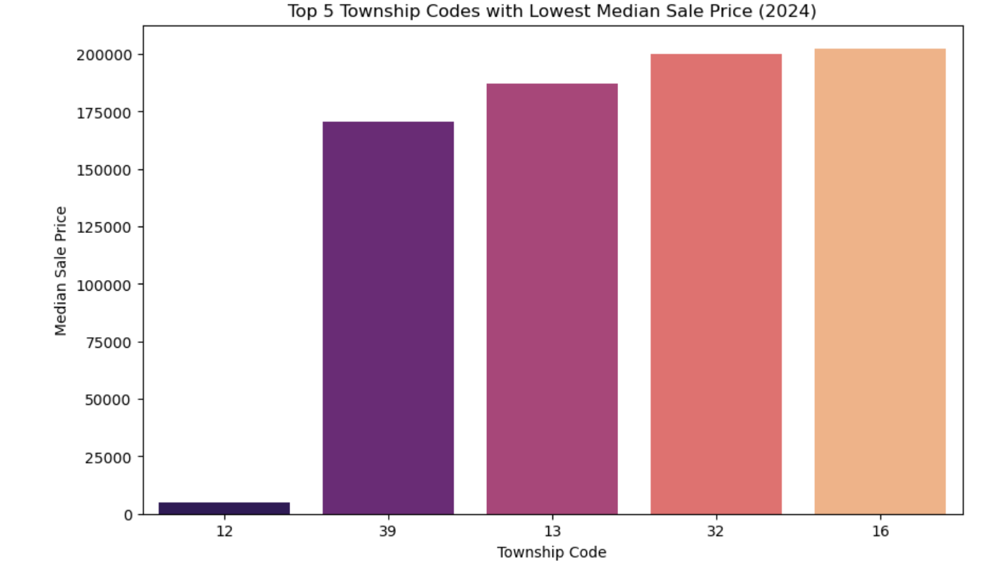

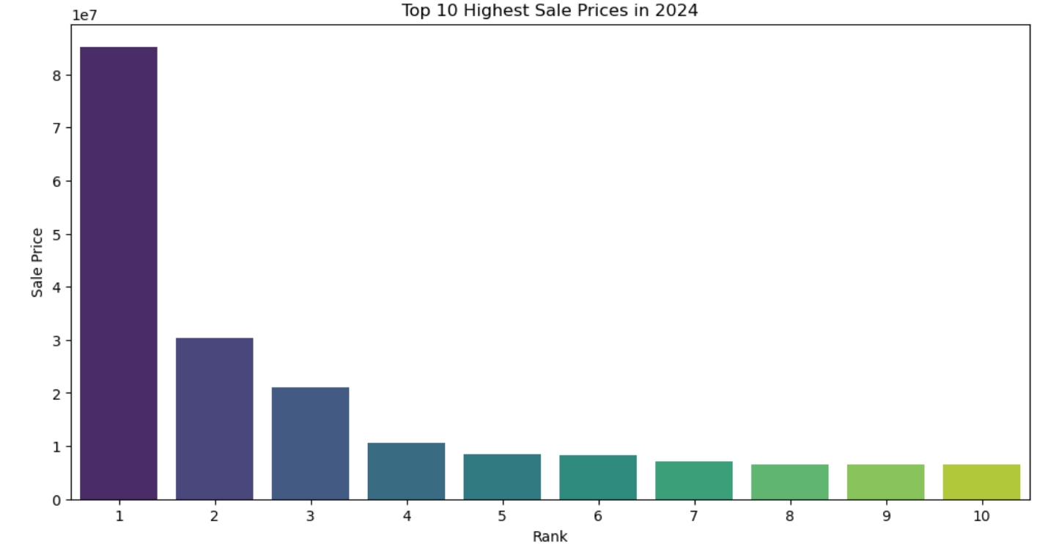

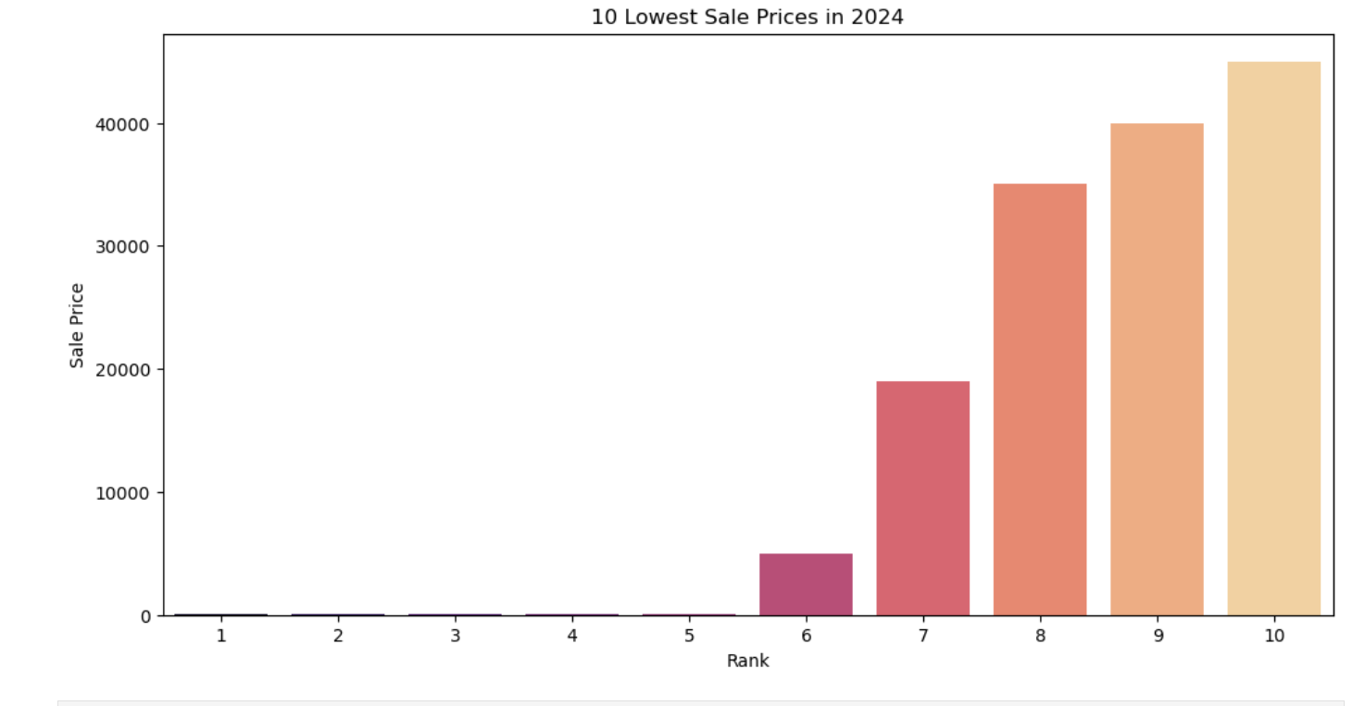

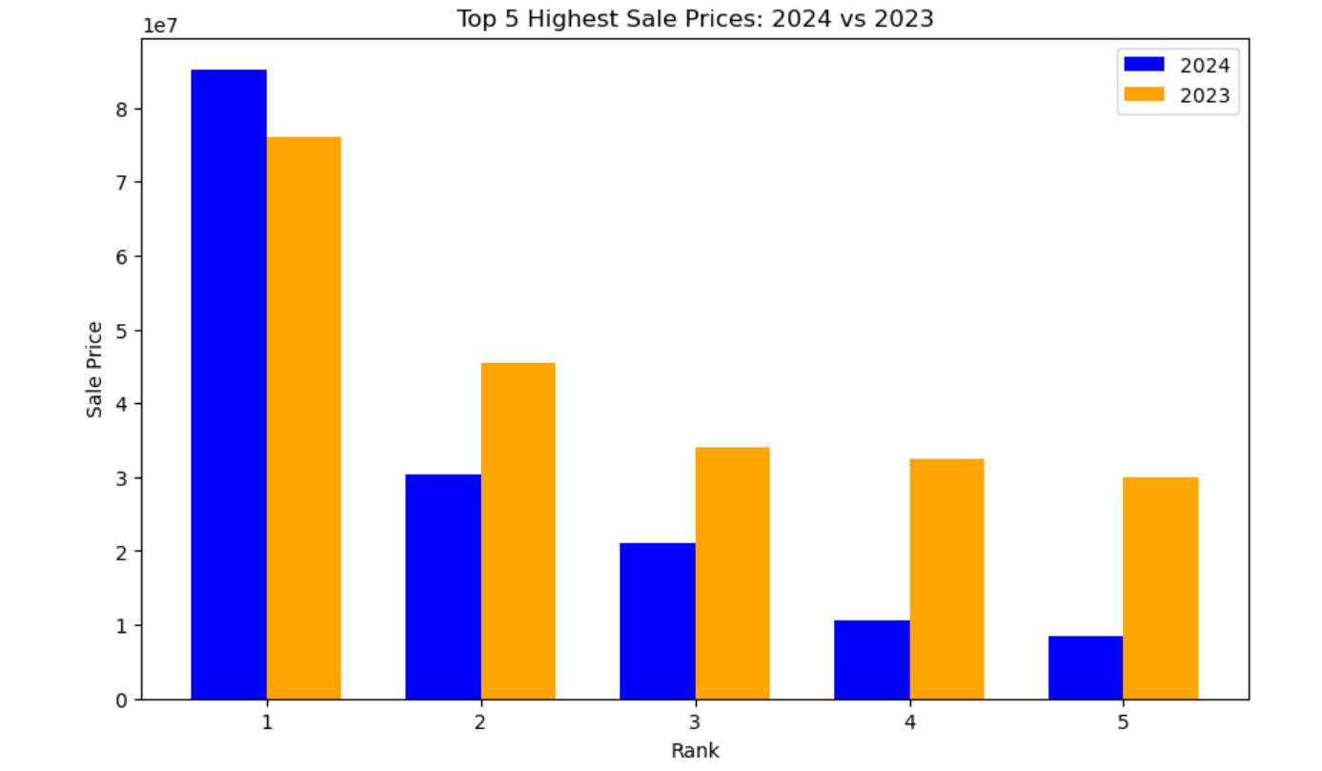

2. I’m not writing half a page for each visualization.

Mostly because this is unnecessary torment which I decline.

What’s the point of a going through the rigor of making great graphs if you have to write   
 a million words to explain each of them.

This is maddening.

For anyone desiring to read a bunch about charts and how to interpret the obvious, I   
 recommend reading Technical Analysis for Absolute Beginners: Learn How to Read   
 Charts and Analyze Markets with Confidence by Peter Kents.

This cited text can be substituted for my half page of text for each graph.

3. Highest, highest median township, lowest median township, 2024 real estate sales.

4. Keywords: highest, lowest, median, sales price, 2024.

Assessor - Parcel Sales. Available at <https://catalog.data.gov/dataset/?tags=property-tax&res_format=JSON>. Accessed 20 SEPT 2025.